**Project – 5**

**Objective: Establish connectivity between an Remote/on-premises network and an Azure Virtual Network to enable seamless communication and resource access across hybrid environments.**

**Step – 1**

Assess On-premises Network Environment: Evaluate the existing on-premises network infrastructure, including network topology, IP addressing scheme, and connectivity requirements for applications and services hosted on-premises.

**Step – 2**

Create Azure Virtual Network: Provision an Azure Virtual Network (VNet) in the Azure portal, defining IP address ranges and subnets that align with your remote/on-premises network configuration. Choose an appropriate location and resource group for the VNet deployment.

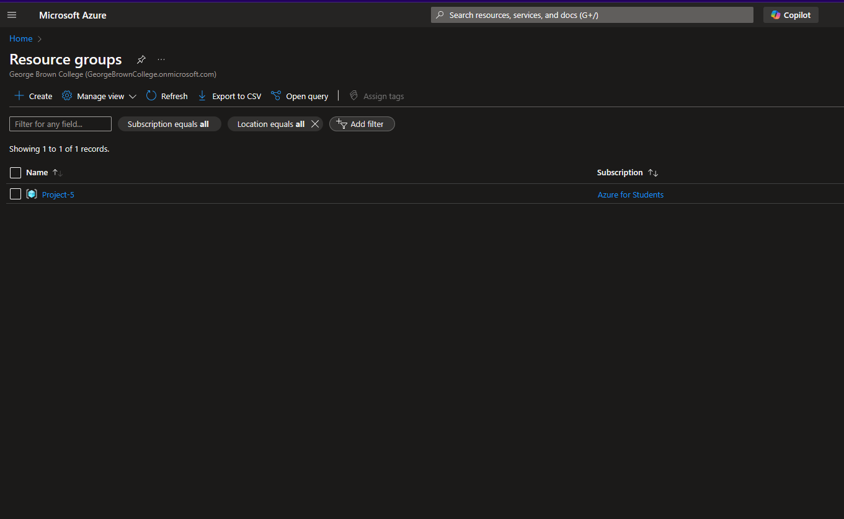

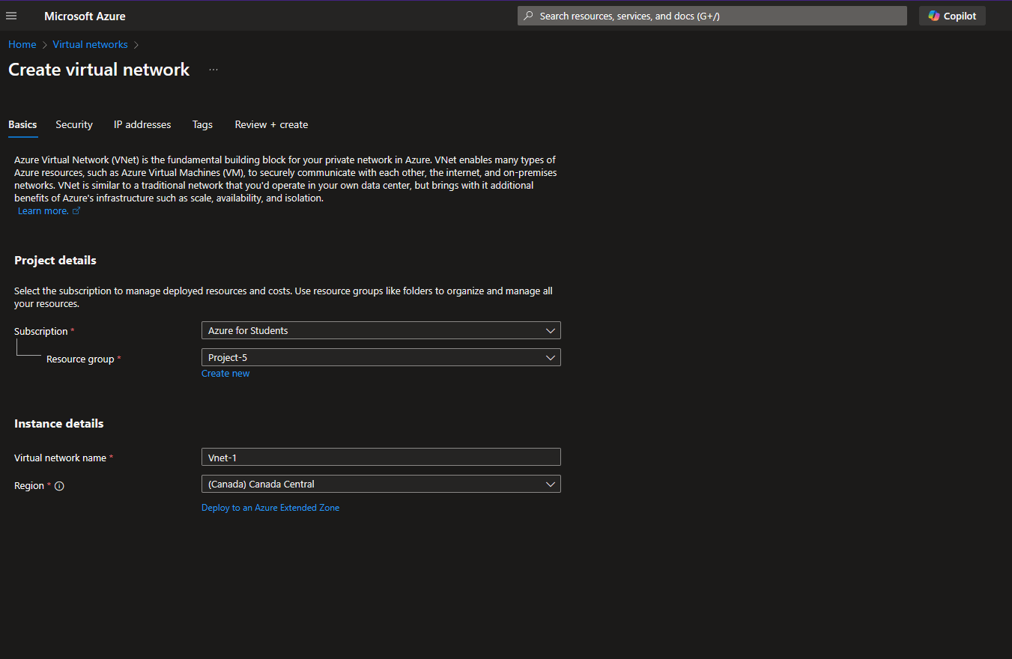

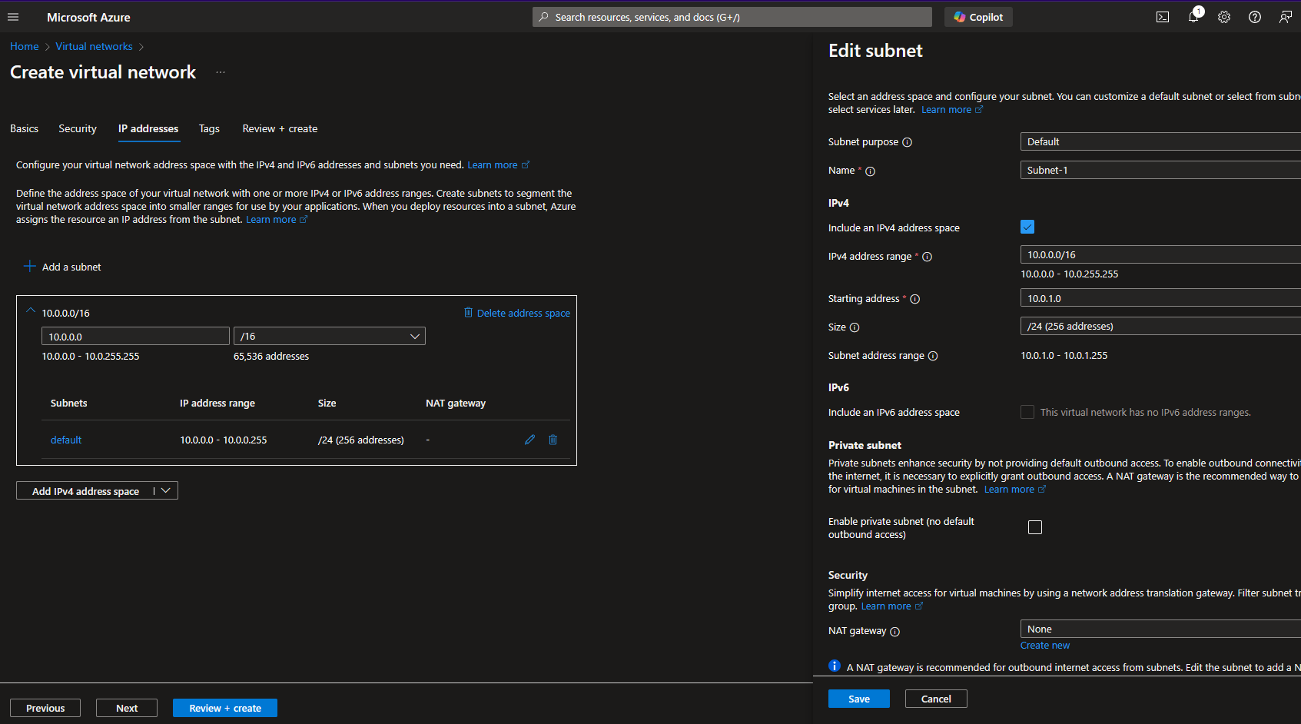

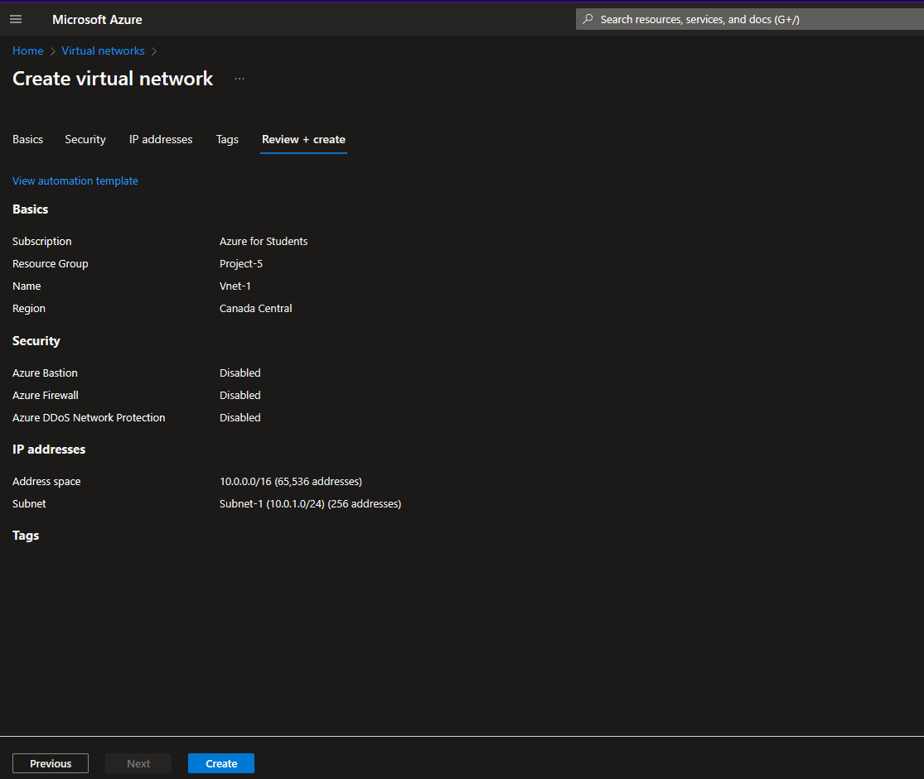

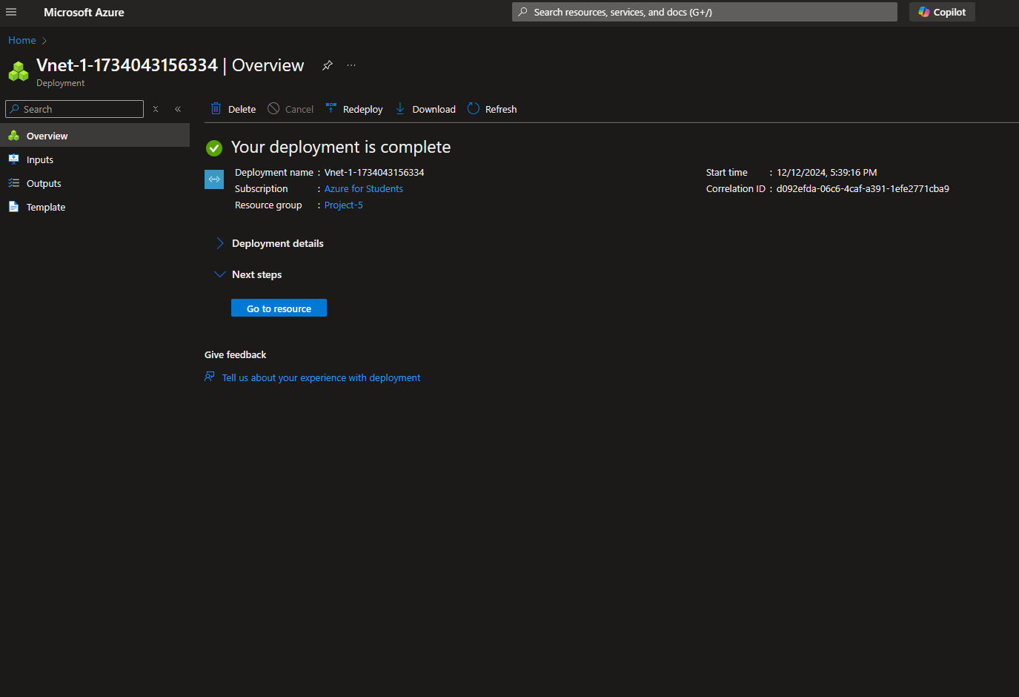

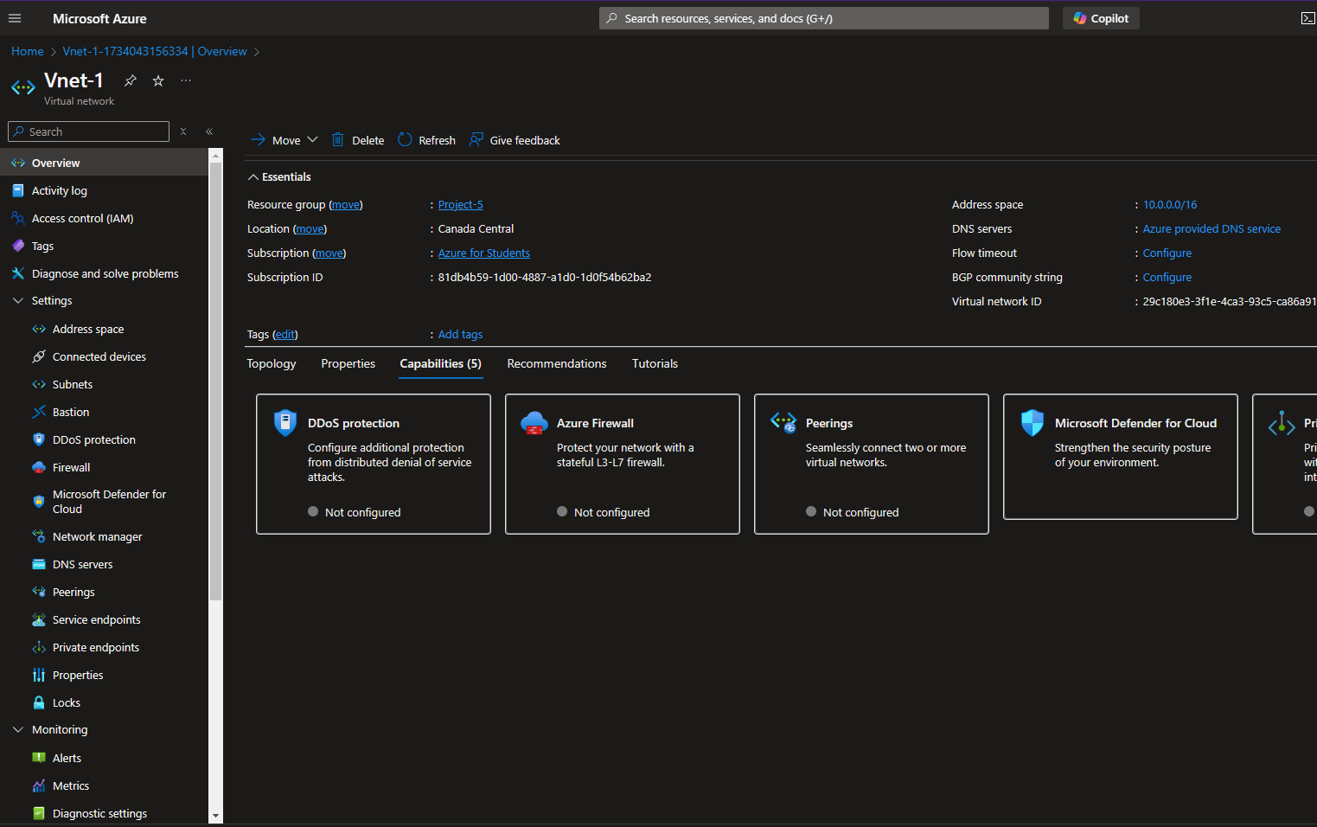

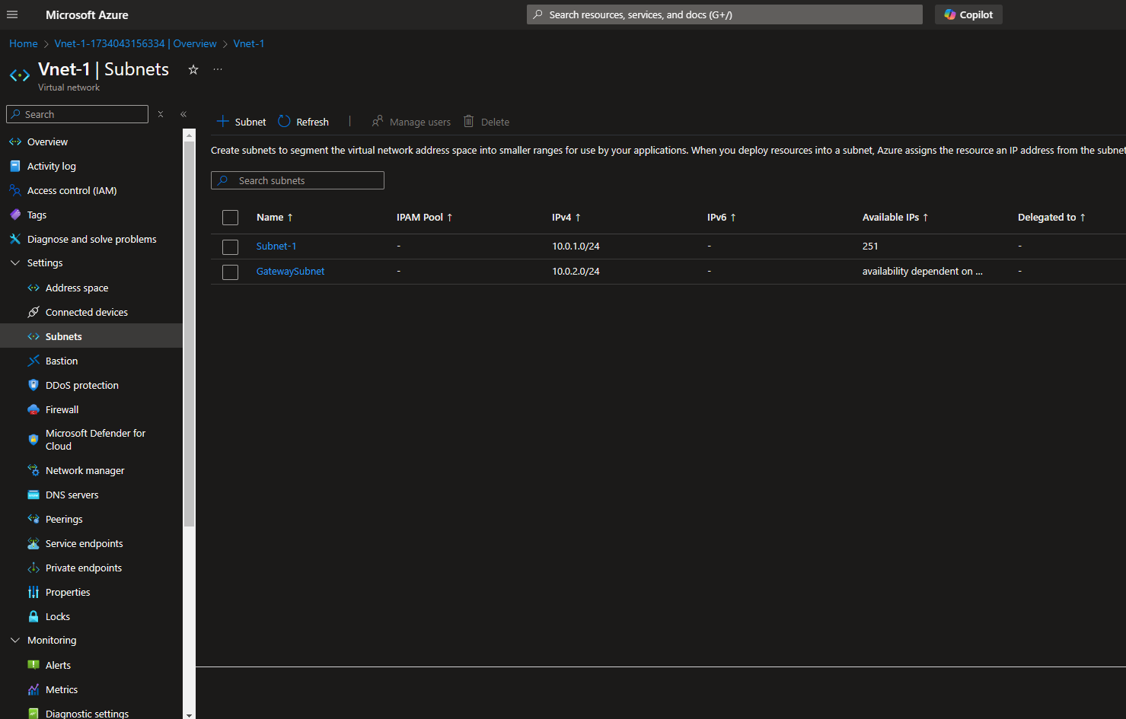

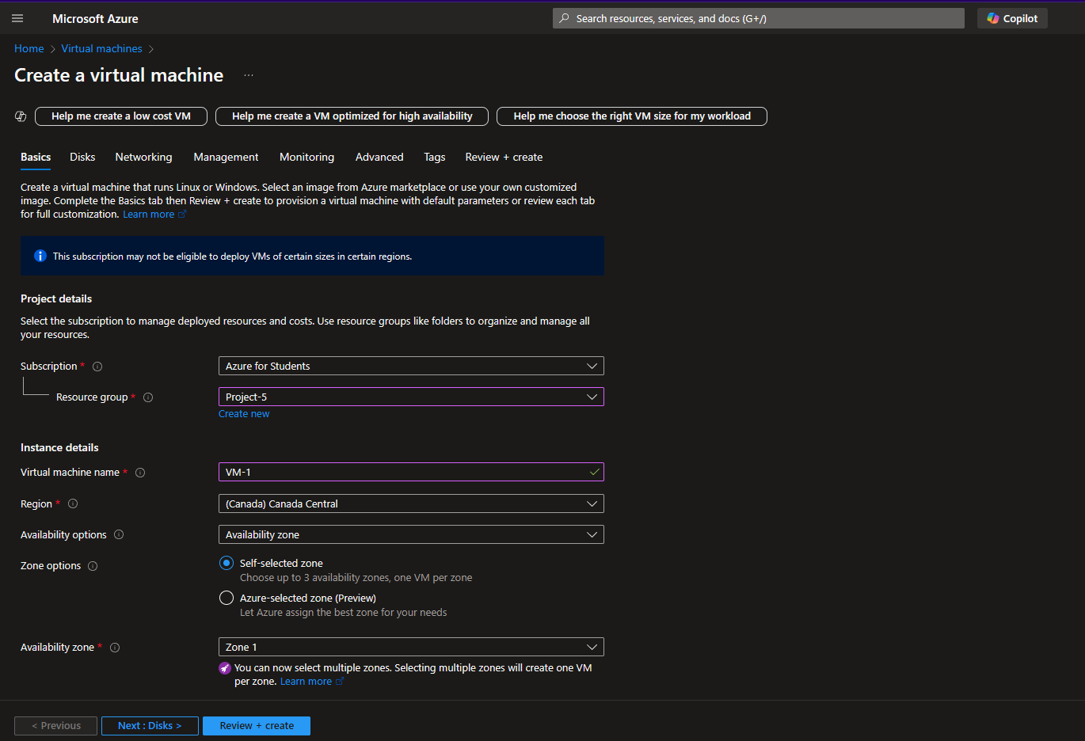

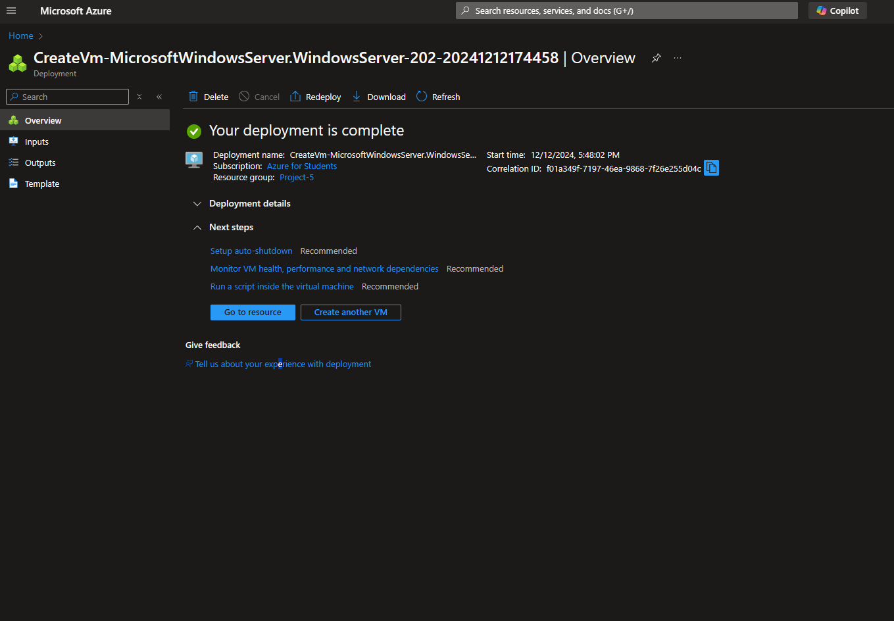

**Step - 3**

Deploy Local Network Gateway: Create a Local Network Gateway (LNG) in Azure to represent the on-premises network. Specify the public IP address or address range of the on-premises VPN device, along with the corresponding private IP address range.

**Step – 4**

Configure On-premises VPN Device: Configure the VPN device on the on-premises network (e.g., VPN router, firewall) to establish a VPN tunnel with the Azure VPN Gateway. Ensure that the VPN device settings (IKEv2/IPsec parameters, pre-shared key) match the configuration of the Azure VPN Gateway.

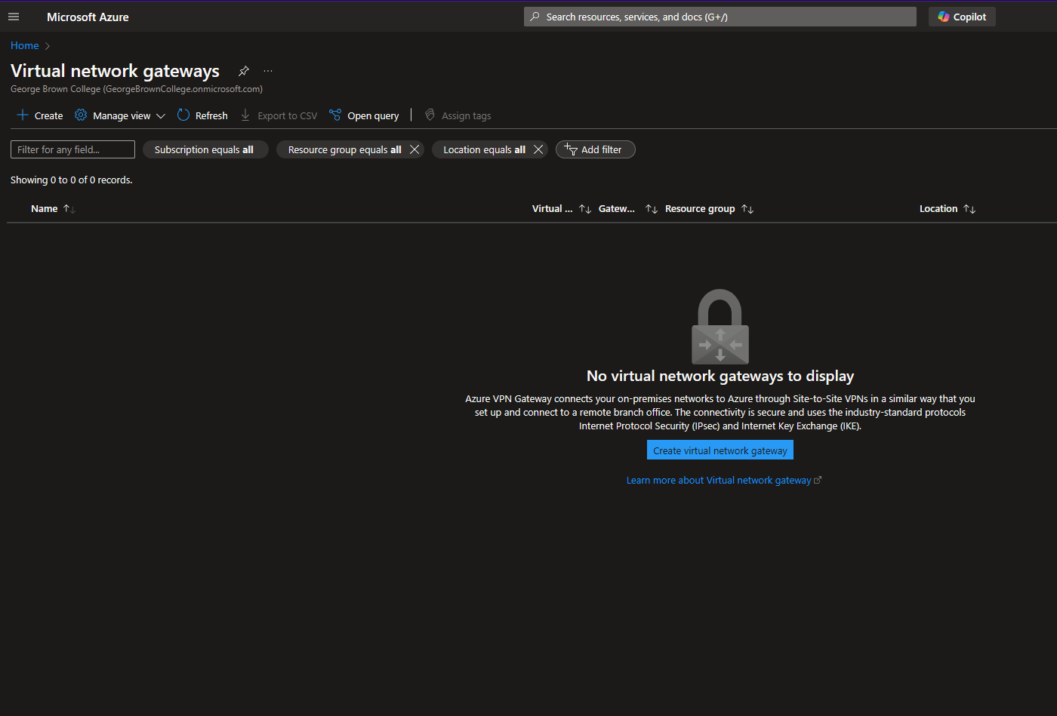

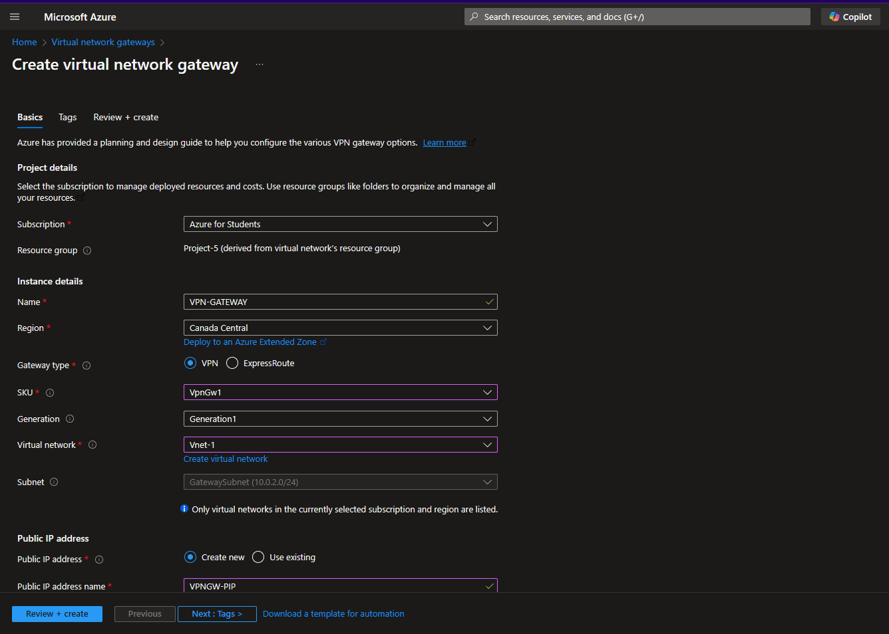

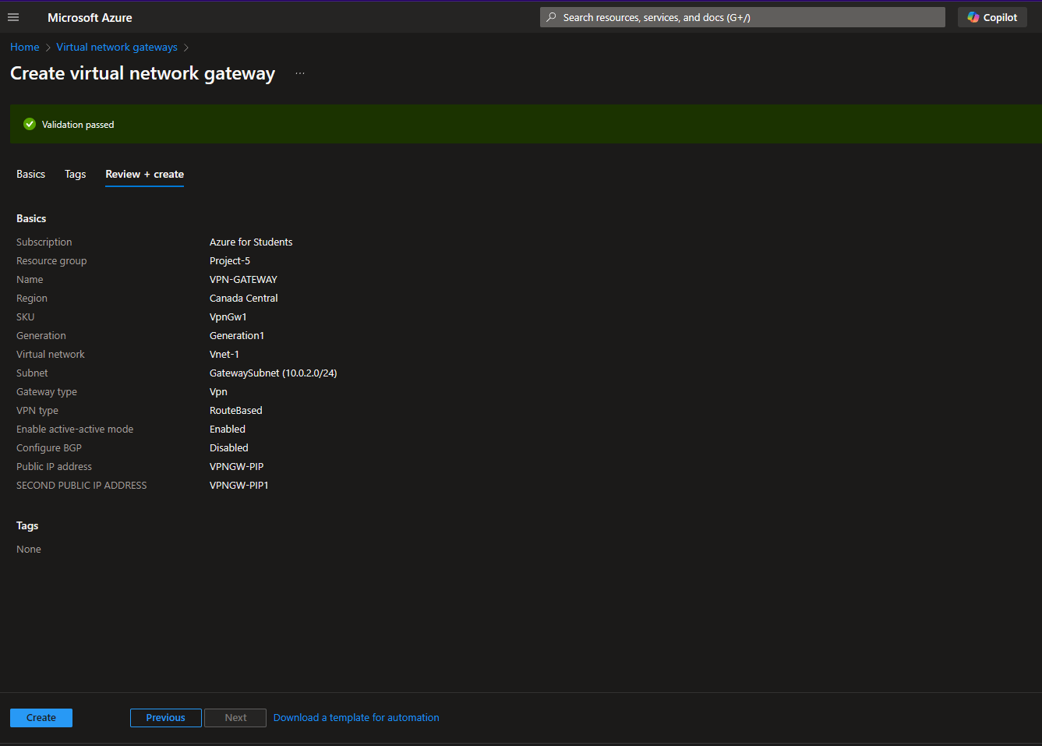

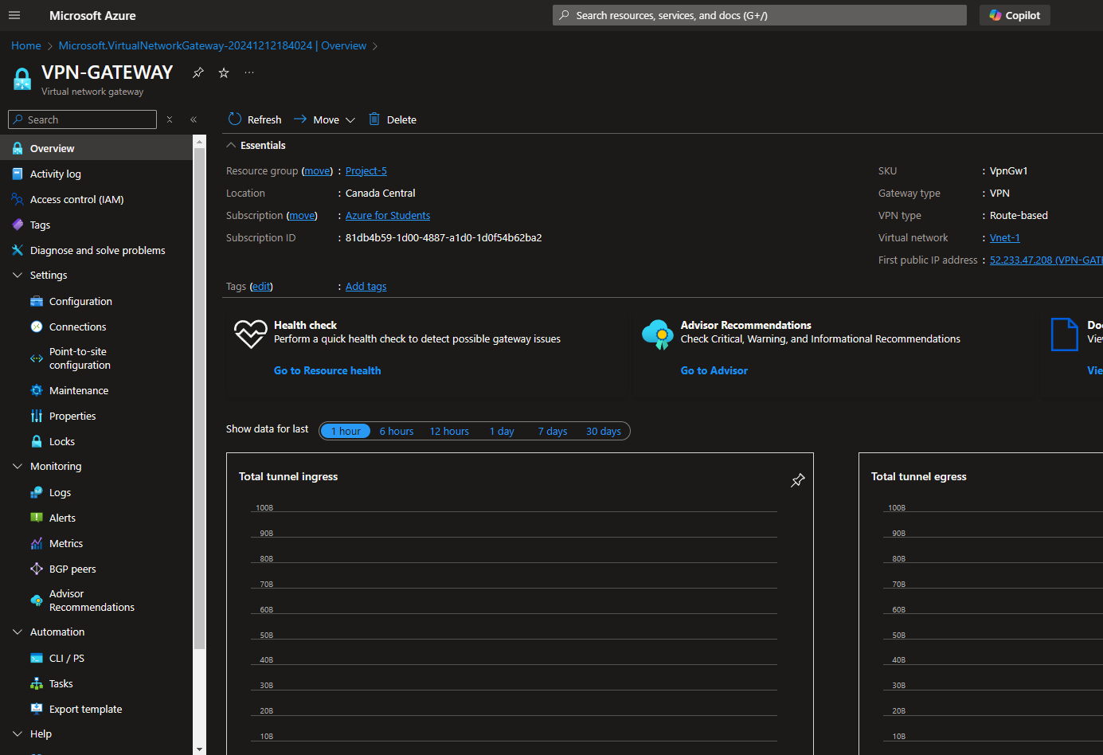

**Step – 5**

Establish VPN Connection: Initiate the VPN connection between the Azure VPN Gateway and the on-premises VPN device. Verify the connectivity status and troubleshoot any connectivity issues using Azure VPN diagnostics and logs.

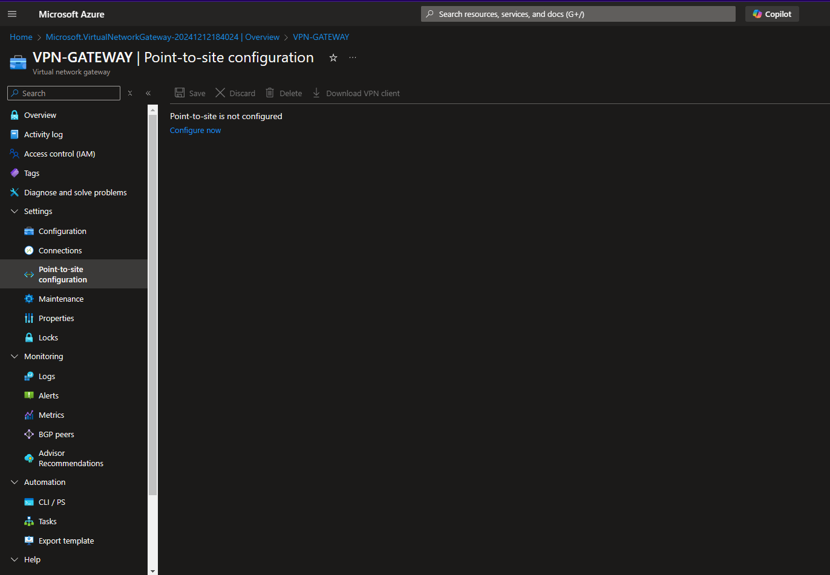

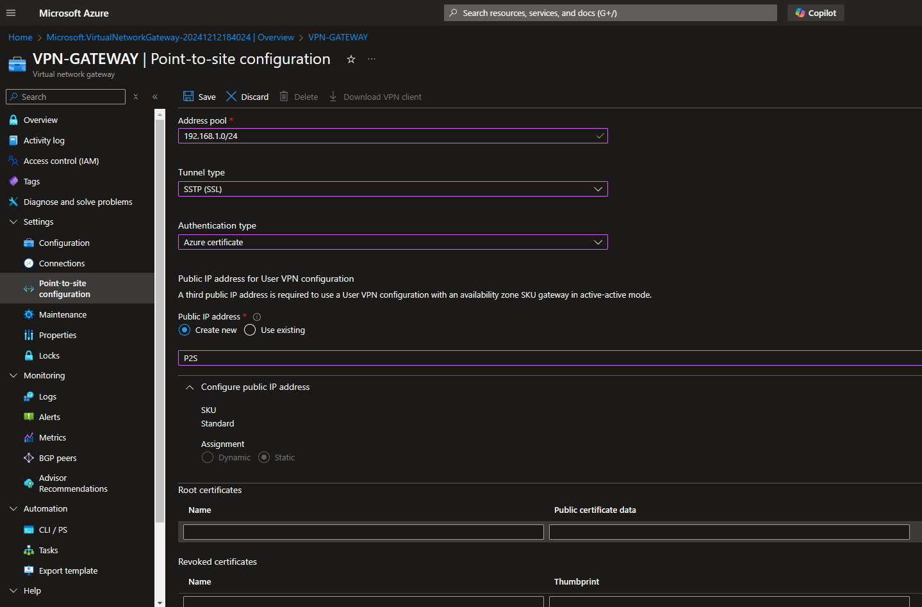

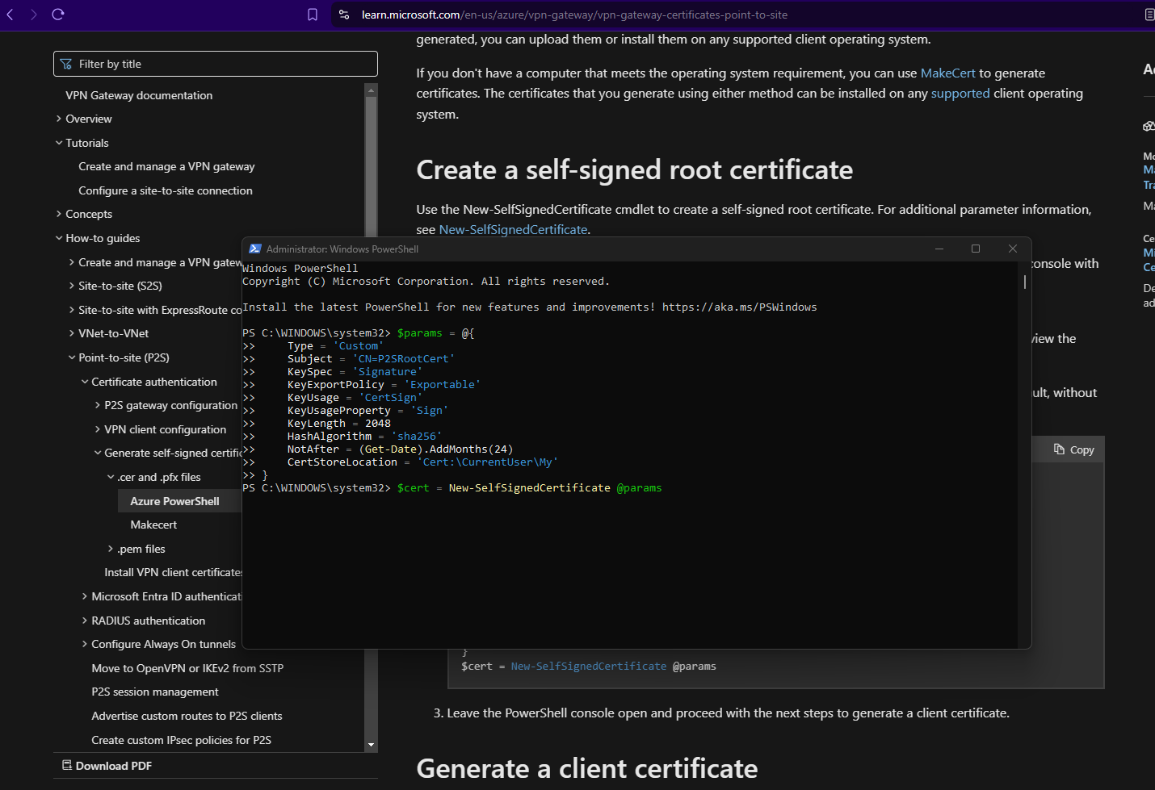

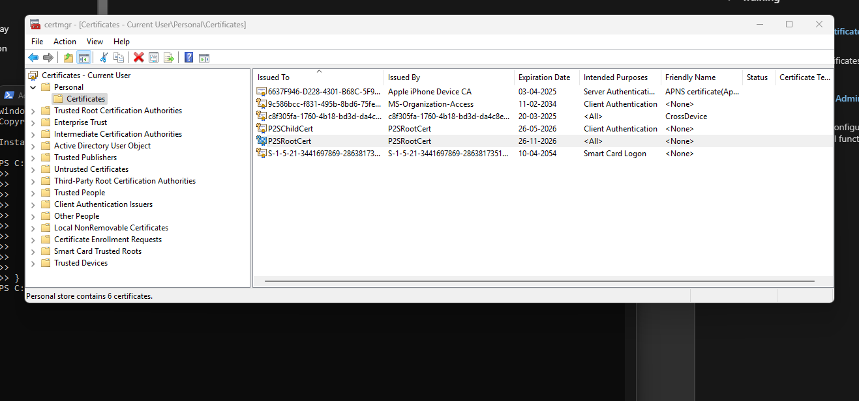

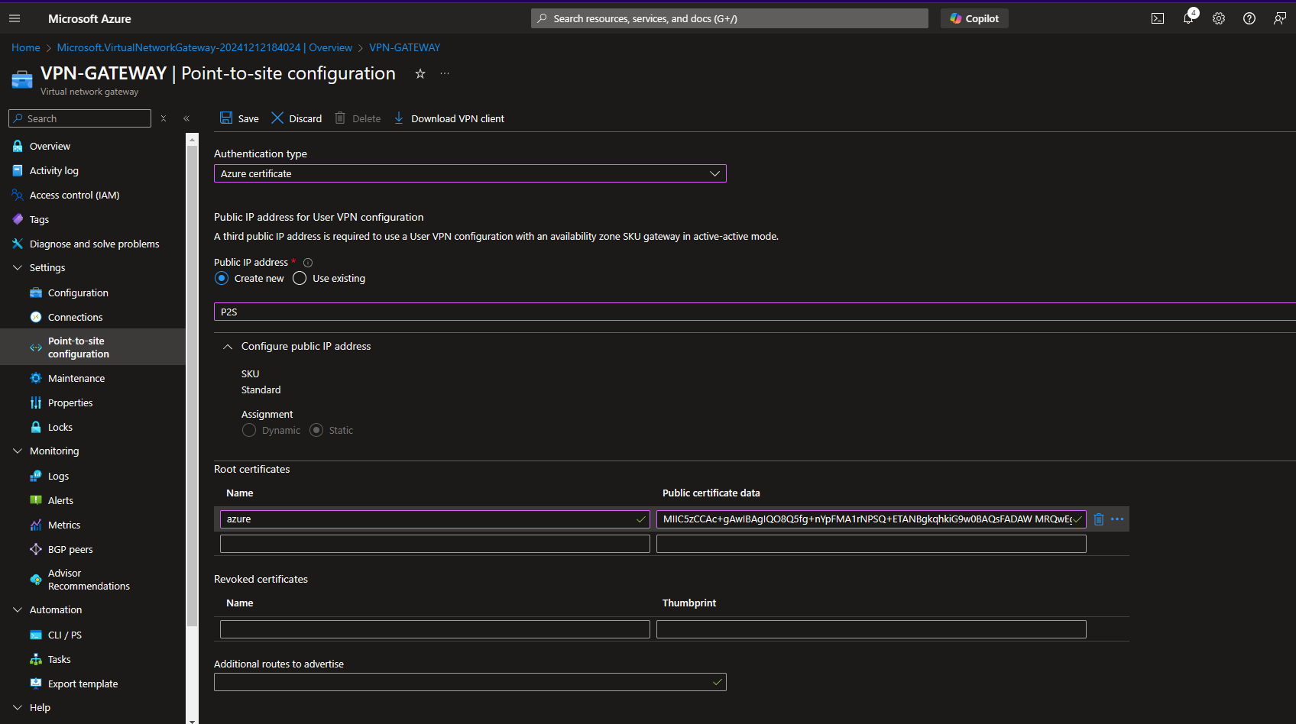

**Step – 6**

Configure Network Routing: Configure routing settings on both the Azure Virtual Network and the on-premises network to enable traffic flow between the two networks. Define route tables, user-defined routes, and network security rules to control traffic forwarding and filtering.

**Step – 7**

Test Connectivity and Resource Access: Validate the connectivity between resources hosted on the Azure Virtual Network and the on-premises network. Test access to on-premises applications, file shares, and services from Azure VMs, and vice versa.

